Signal detection:

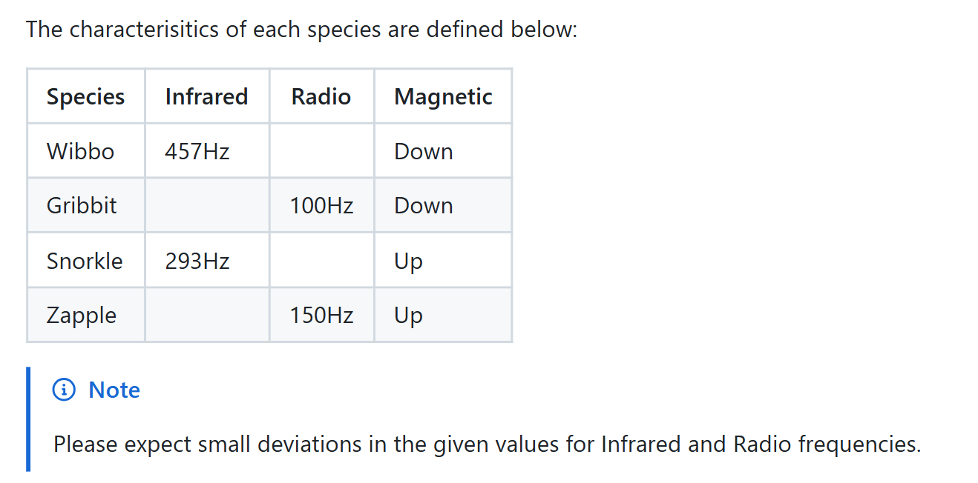

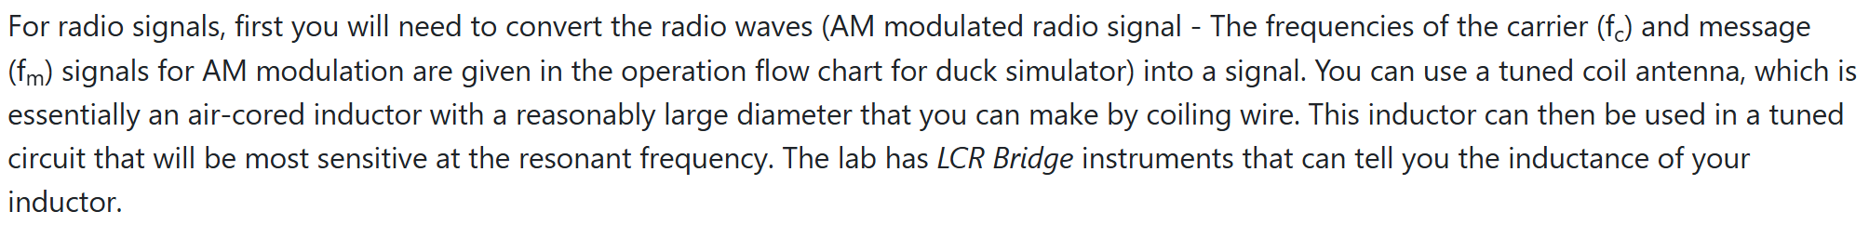

Flow chart for duck simulator:

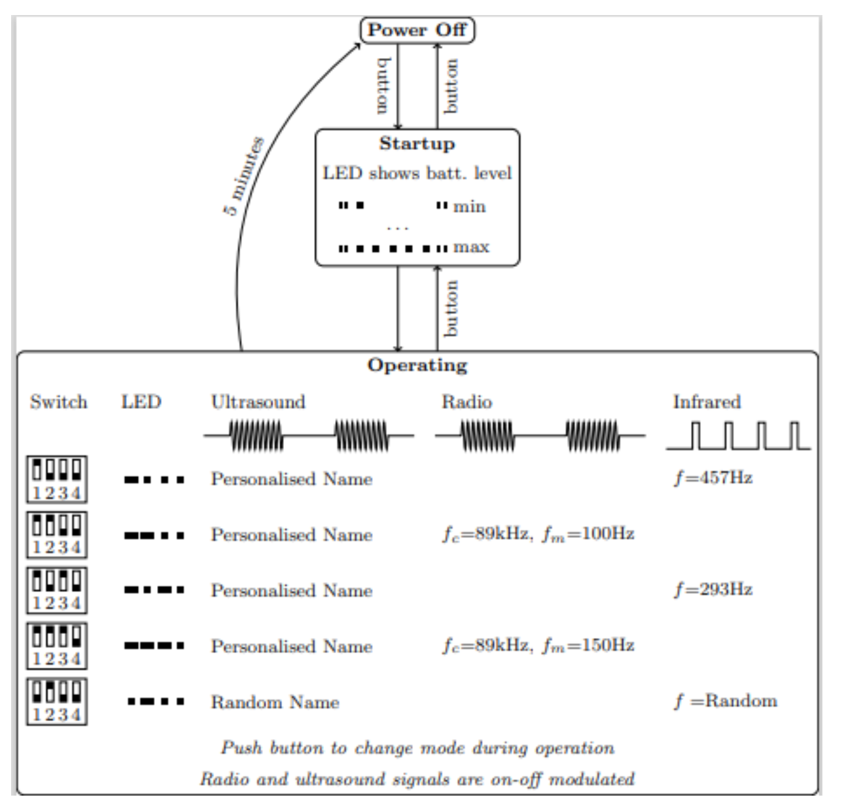

Radio:

1. The duck emits an AM radio wave with a carrier frequency of 89kHz, modulated at either 100Hz or 150Hz, which we must convert into a usable voltage signal. In order to do this we can use a coil of wire as an antenna. Since there is a changing magnetic field when the radio wave passes through the coil this will induce a voltage according to faradays law, we can adjust the number of turns in the coil in order to increase or decrease the voltage induced. This coil also can be used as an inductor in our tuned (resonance) circuit.
2. Then, we need to build a parallel LC resonance circuit to amplify the desired 89kHz signal and suppress noise at other frequencies, the values of the inductance and capacitor (value of inductance of our coil can be measured using the LCR bridge in the lab) should be such that the circuit resonates at 89k = 1/(2pi\*sqr(LC)). We want the rest of the frequencies to be filtered out to remove noise at these frequencies. The resonance circuit will also be built using a PCB as this is lighter than a breadboard (one of the requirements of the rover is for it to be less than 750g).

1. We then need to demodulate this signal. We can do this via an envelope detector. An envelope detector works by using a diode to rectify the high-frequency AM signal, allowing only the positive half-cycles to pass. A capacitor is then used to charge up to the peaks of the rectified signal, while a resistor slowly discharges the capacitors between peaks. Due to this charging and discharging behaviour we see this ripple effect, hence we need to use a low pass filter to smooth out the signal. Then we have the amplitude envelope of the original signal, which we then measure the frequency of to find the species of the duck. However note that this assumes the diode is ideal, when in reality there will be a voltage drop, so maybe we can use another diode type that has a small voltage drop?

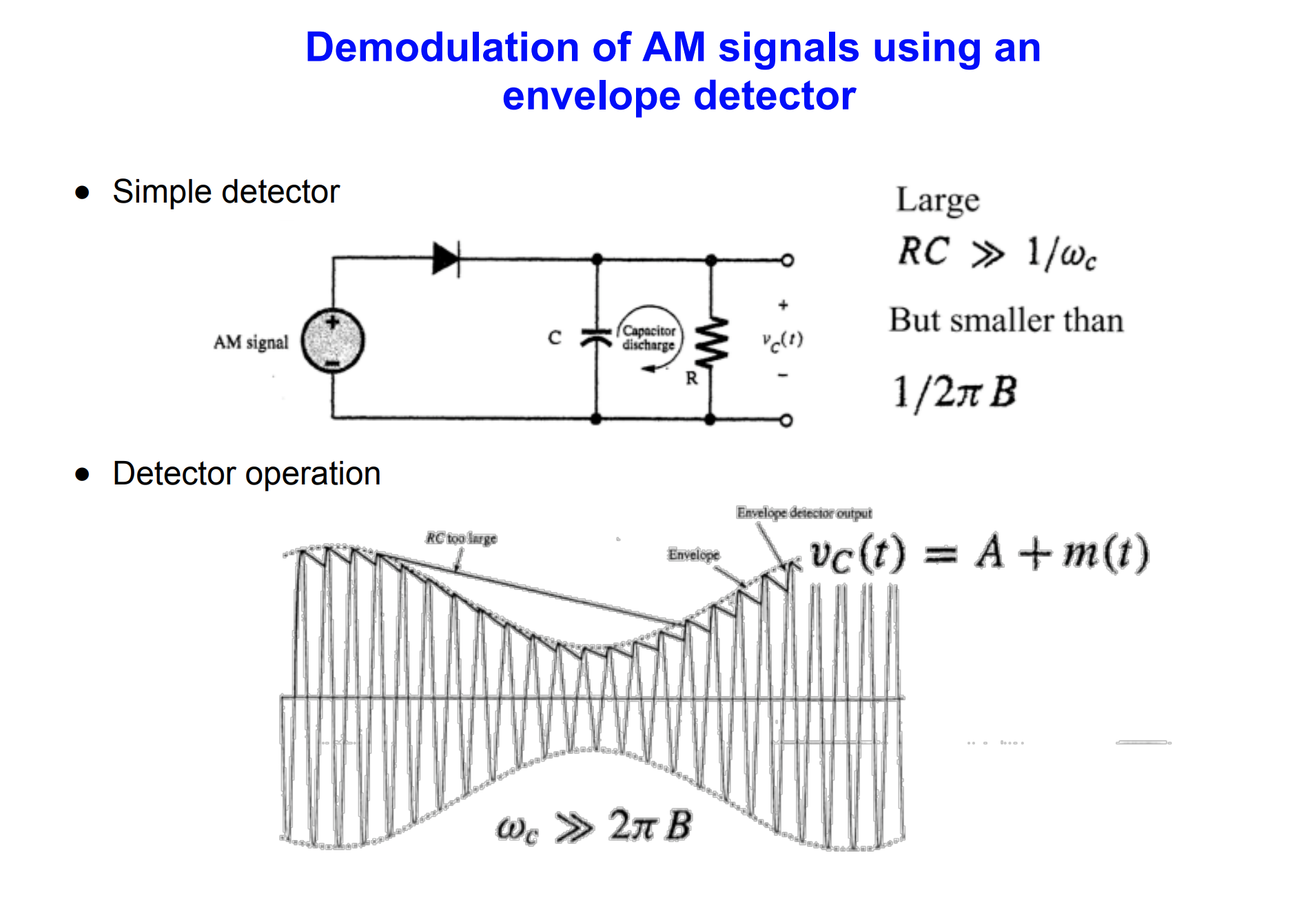

1. Finally, we must measure the frequency of our demodulated signal. If the frequency is 100Hz, then the duck is Gribbit. If the frequency is 150Hz, the duck is Zapple. This can be done using a microcontroller.